Proposed Set of Standard Components for Measurement Education Curricula
Thank you for providing your feedback on the proposed set of standard components for measurement education curricula in both clinical rehabilitation programs and research (PhD) rehabilitation science programs. We developed these recommended standard components based on the COSMIN checklist. This questionnaire is the first of two rounds of surveys, so you will have the opportunity to revise your answers in the second round.
In these surveys, you will be asked to rate the importance of each measurement component to both clinical and research curricula. Additionally, you will be asked open-ended questions related to the content, classification of Blooms taxonomy levels, and feasibility of including these components in education curricula.
Once we have received all responses, we will summarize the results and formulate a second questionnaire. You should receive this sometime in July 2017. Please return the completed questionnaire to Shannon Juengst by May 31st: Shannon.Juengst@utsouthwestern.edu or email for mailing address if preferred.
We assure you that your individual responses will be strictly confidential to the Curriculum Task Force and will not be divulged to any outside party, including other panelists.

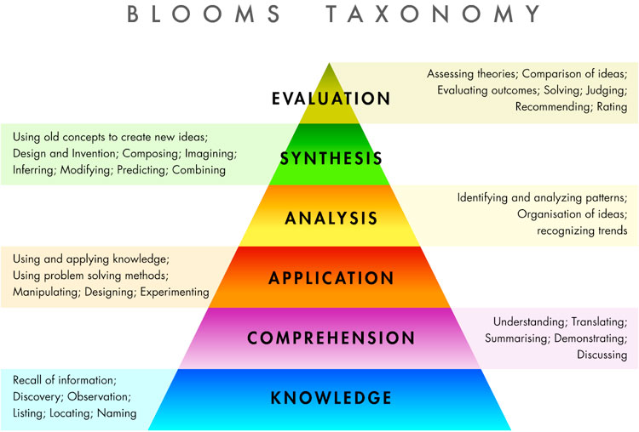

http://rationalexpressions.blogspot.com/2014/05/blooms-taxonomy-and-ease-of-appearing.html
INSTRUCTIONS: In the table below, you will find our proposed Set of Standard Component for Measurement Education. After reviewing all components, please rate the IMPORTANCE of each component for both Clinical and Research curricula on the scales provided in the Table (1=not important to 5=very important) and answer the following questions:

- Are there any topics/components that you would add to those listed?

- Do you have any suggestions or revisions for the levels of Bloom’s Taxonomy for any of the components?

- Do you think that implementing these components is equally important and feasible across all rehabilitation science (clinical and research) programs? Please share your rationale:

- Do you have any additional suggestions or comments that could be important for developing recommendations for a set standard of components for rehabilitation science educational curricula?
 |  | Clinician |  | Researcher
Topic | Skill level | Importance  (1) Not to (5) Very | Bloom’s Taxonomy* | Importance  (1) Not to (5) Very | Bloom’s Taxonomy*
Levels of Measurement | Introductory | 1 2 3 4 5 | Application | 1 2 3 4 5 | Application
Standard Error of Measurement | Introductory | 1 2 3 4 5 | Comprehension | 1 2 3 4 5 | Evaluation
Fairness in testing | Introductory | 1 2 3 4 5 | Comprehension | 1 2 3 4 5 | Comprehension
Face validity | Introductory | 1 2 3 4 5 | Comprehension | 1 2 3 4 5 | Application
Classical Test Theory | Moderate | 1 2 3 4 5 | Comprehension | 1 2 3 4 5 | Evaluation
Instrument development process | Moderate | 1 2 3 4 5 | Comprehension | 1 2 3 4 5 | Application
Qualitative development of conceptual framework | Moderate | 1 2 3 4 5 | Comprehension | 1 2 3 4 5 | Analysis
Development of instrument content | Moderate | 1 2 3 4 5 | [not included] | 1 2 3 4 5 | Comprehension
Purposes of measurement instruments | Moderate | 1 2 3 4 5 | Application | 1 2 3 4 5 | Evaluation
Reliability Indices | Moderate | 1 2 3 4 5 | Comprehension | 1 2 3 4 5 | Evaluation
Minimal detectable change | Moderate | 1 2 3 4 5 | Comprehension | 1 2 3 4 5 | Evaluation
Validity Indices | Moderate | 1 2 3 4 5 | Comprehension | 1 2 3 4 5 | Analysis
Hypothesis Testing | Moderate | 1 2 3 4 5 | Application | 1 2 3 4 5 | Evaluation
Cross-cultural validity | Moderate | 1 2 3 4 5 | Application | 1 2 3 4 5 | Evaluation
Content validity | Moderate | 1 2 3 4 5 | Comprehension | 1 2 3 4 5 | Evaluation
Interpretability | Moderate | 1 2 3 4 5 | Evaluation | 1 2 3 4 5 | Evaluation
Clinical Utility | Moderate | 1 2 3 4 5 | Evaluation | 1 2 3 4 5 | Evaluation
Floor and ceiling effects | Moderate | 1 2 3 4 5 | Knowledge | 1 2 3 4 5 | Analysis
Responsiveness | Moderate to Difficult | 1 2 3 4 5 | Comprehension | 1 2 3 4 5 | Evaluation
MCID | Moderate to Difficult | 1 2 3 4 5 | Comprehension | 1 2 3 4 5 | Analysis
Criterion Validity | Difficult | 1 2 3 4 5 | Comprehension | 1 2 3 4 5 | Evaluation
Construct Validity | Difficult | 1 2 3 4 5 | Comprehension | 1 2 3 4 5 | Evaluation
Factor Analysis or IRT (Structural Validity) | Difficult | 1 2 3 4 5 | Knowledge | 1 2 3 4 5 | Analysis
Ecological Validity | Difficult | 1 2 3 4 5 | Knowledge | 1 2 3 4 5 | Comprehension
Contemporary Measurement Theory | Difficult | 1 2 3 4 5 | Comprehension | 1 2 3 4 5 | Evaluation
Generalizability Theory | Difficult | 1 2 3 4 5 | [not included] | 1 2 3 4 5 | Comprehension

